**NEWRELIC CONFIGURATION (APM) FOR API IN PROD:**

APM gives server

APM configuration is for backend (api) and RUM is for front end (UI) **{RUM is browser monitoring}**

**Have to request for newrelic license by creating JIRA  as following**

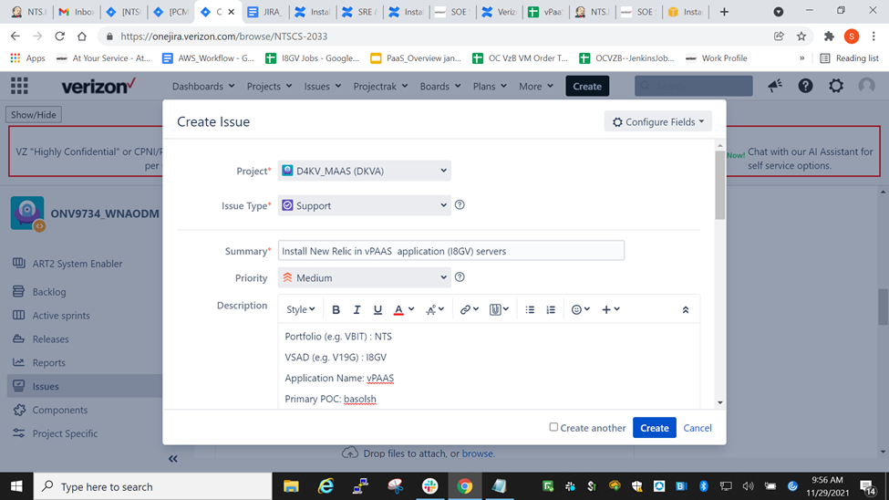

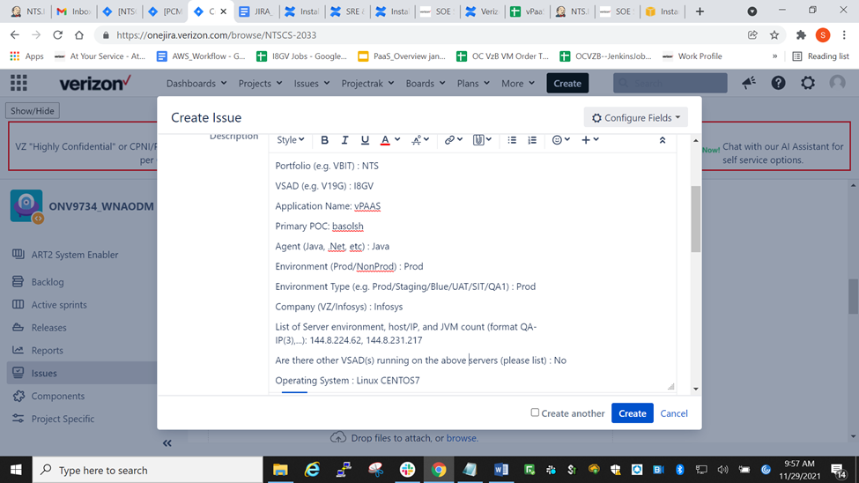

Portfolio (e.g. VBIT) : NTS

VSAD (e.g. V19G) : I8GV

Application Name: vPAAS

Primary POC: basolsh

Agent (Java, .Net, etc) : Java

Environment (Prod/NonProd) : Prod

Environment Type (e.g. Prod/Staging/Blue/UAT/SIT/QA1) : Prod

Company (VZ/Infosys) : Infosys

List of Server environment, host/IP, and JVM count (format QA-IP(3),...): 144.8.224.62, 144.8.231.217

Are there other VSAD(s) running on the above servers (please list) : No

Operating System : Linux CENTOS7

JVM Runtime User ID (e.g., weblogic, tomcat) : tomcat

AWS/OCI/On-Prem/Kubernetes : AWS

Email Notification : shilpa.rani.basole@verizon.com

App name format needed in new relic : vPAAS_I8GV

Jira -à<https://onejira.verizon.com/browse/DKVA-4420>

**Will get license in the email and have to follow this confluence page to do configurations on server.**

Reference url: <https://oneconfluence.verizon.com/display/NewRelic/Installing+and+Configuring+APM+Agents+on+various+Application+Platforms>

STEPS:

1. Login into the api server as root and cd /apps/tools
2. Download newrelic-java.zip from artifactory by command —- wget h[**ttps://oneartifactoryprod.verizon.com/artifactory/D4KV_Datadog/NonProd/newrelic-java.zip**](https://oneartifactoryprod.verizon.com/artifactory/D4KV_Datadog/NonProd/newrelic-java.zip)
3. 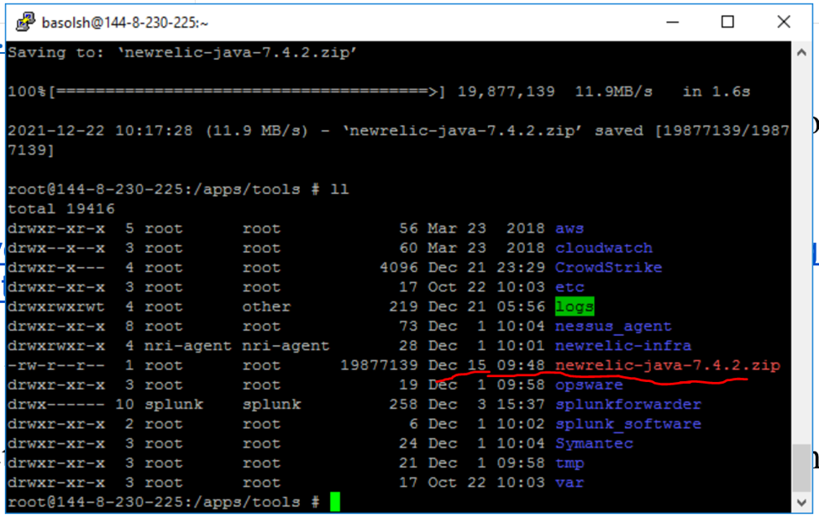

**3. Unzip newrelic-java-7.4.2.zip**

**We will get newrelic folder as shown in following pic**

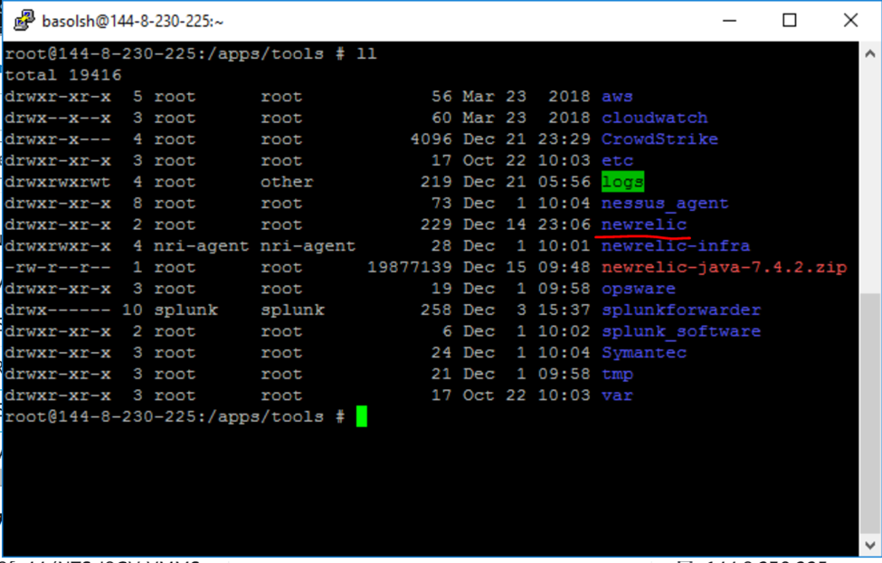

1. **Cd newrelic**
2. **Will will see files as shown in below pic (Before).  Log folder  will get created once .jar is stopped and started as seen in below pic (After part)**

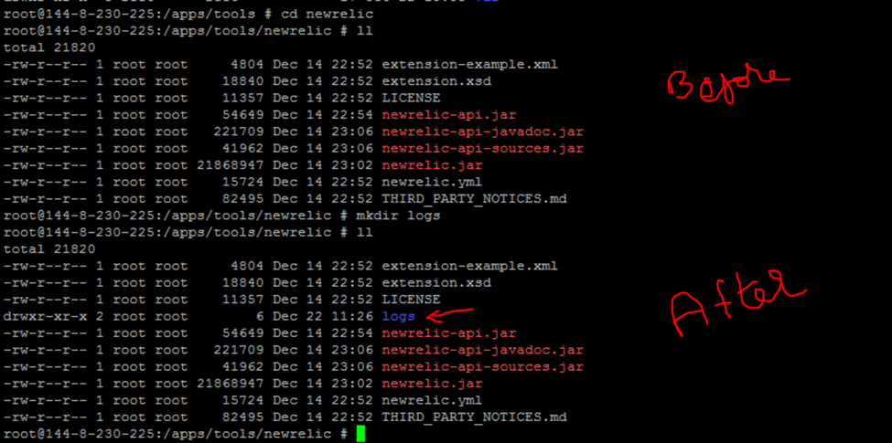

1. **Vi newrelic.yml and add following content**

1. **License key : 16d0b79a0ebe0c375abc3308598d6610FFFFNRAL (we will get this in email from newrelic team after jira is requested )**
2. **app_name : NTS-I8GV-VPAAS-JAVA-PROD-EE1A-GZ**
3. **proxy_host: vzproxy.verizon.com**
4. **proxy_port: 80**
5. **auto_instrument: false (284 line in newrelic.yml)**
6. **Labels:**

**nrVSAD: I8GV**

**nrEVNT: PROD**

**nrPLATFORM: AWS**

**nrPOC: VZ.NET.VPAAS.VzB.Scrum.TEAM@verizon.com**

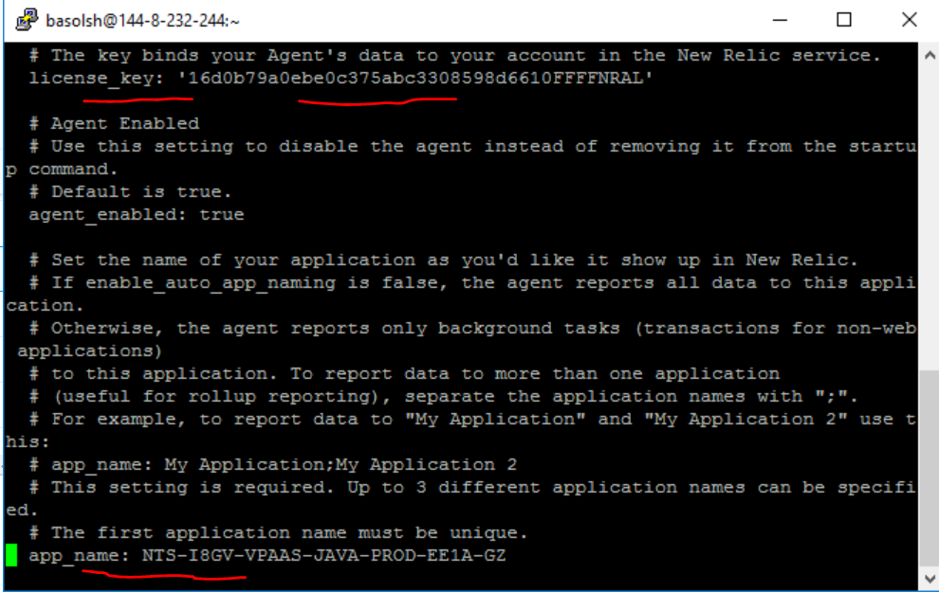

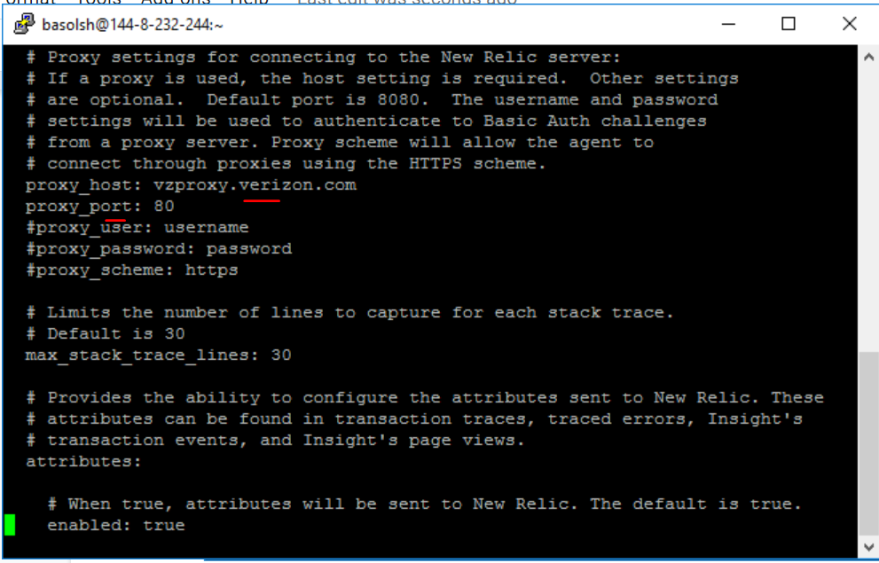

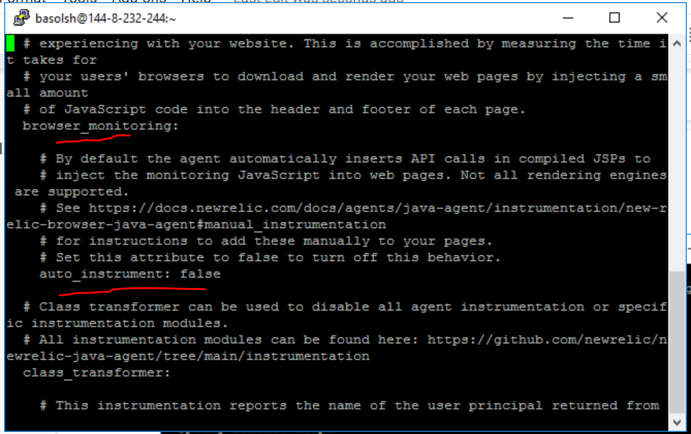

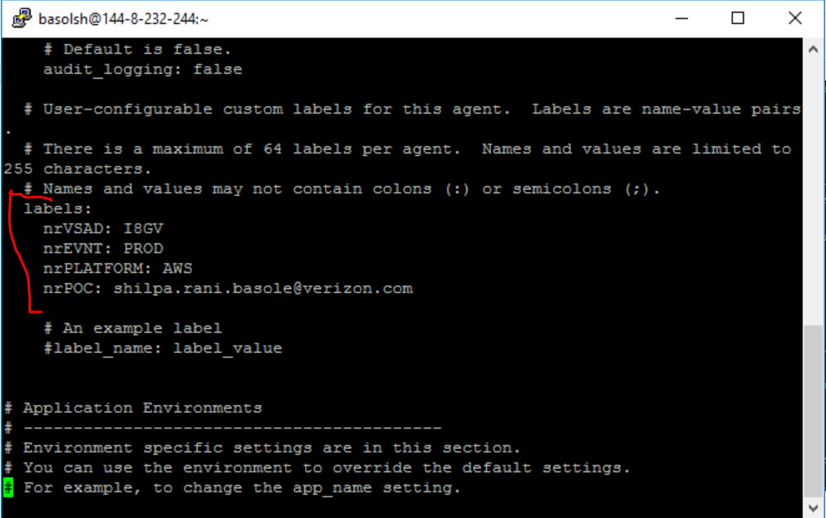

**Once above tags are added in the newrelic.yml, we have to restart vendoruserservice.jar.  For this follow following steps:**

**cd  /apps/opt/vendoruserservice**

**Ps -ef |grep vendoruserservice.jar**

**We will get pid of vendoruserservice.jar and we have kill the process by kill -9 pid**

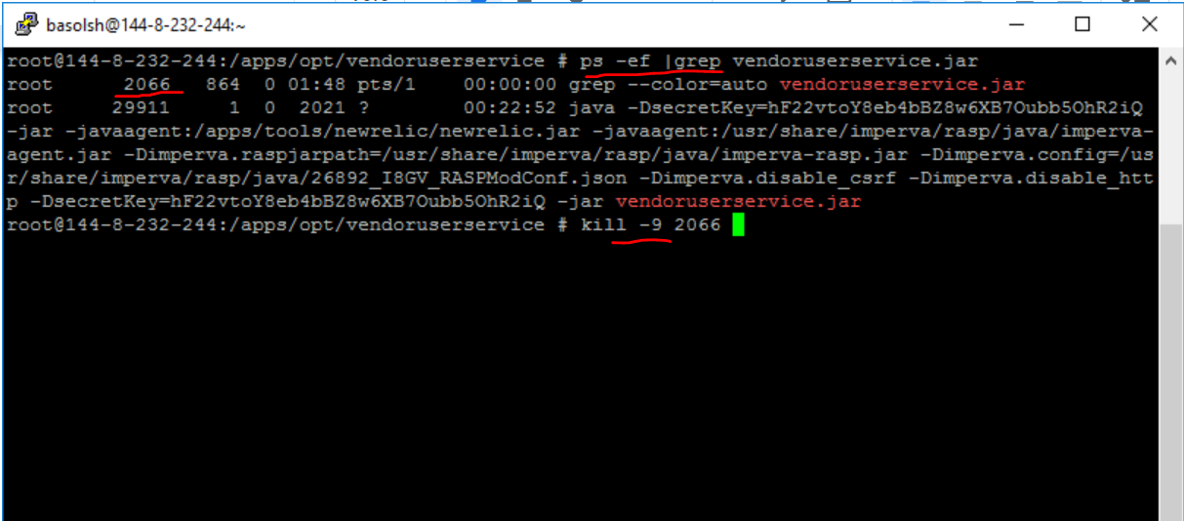

**Then start vendoruserservice.jar with following command—- IN EAST**

**nohup java -DsecretKey=hF22vtoY8eb4bBZ8w6XB7Oubb5OhR2iQ -jar -javaagent:/apps/tools/newrelic/newrelic.jar -javaagent:/usr/share/imperva/rasp/java/imperva-agent.jar -Dimperva.raspjarpath=/usr/share/imperva/rasp/java/imperva-rasp.jar -Dimperva.config=/usr/share/imperva/rasp/java/26892_I8GV_RASPModConf.json -Dimperva.disable_csrf -Dimperva.disable_http -DsecretKey=hF22vtoY8eb4bBZ8w6XB7Oubb5OhR2iQ -jar vendoruserservice.jar &**

**IN WEST —-->**

**nohup java -DsecretKey=pSAhKajuDfasShF22vtoY8eb4bBZ8w6XB7Oubb5OhR2iQN78yBNj#EedFbhT -jar -javaagent:/apps/tools/newrelic/newrelic.jar -jar vendoruserservice.jar &**

**Once vendoruserserivce.jar is started, logs folder will get created in /apps/tools/newerelic**

**Do cd newrelic**

**We will see newrelic_agent.log as following** 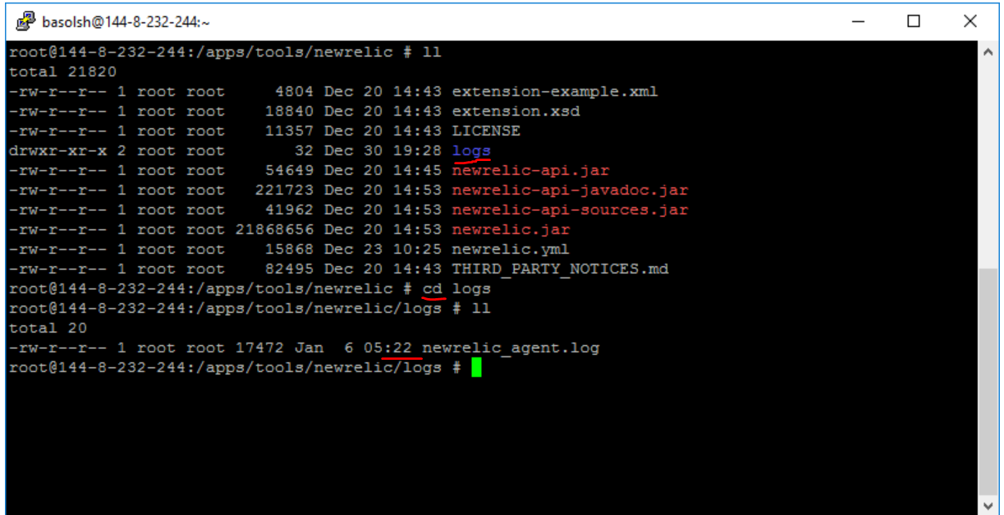

**Do vi newrelic_agent.log, logs will be seen as below**

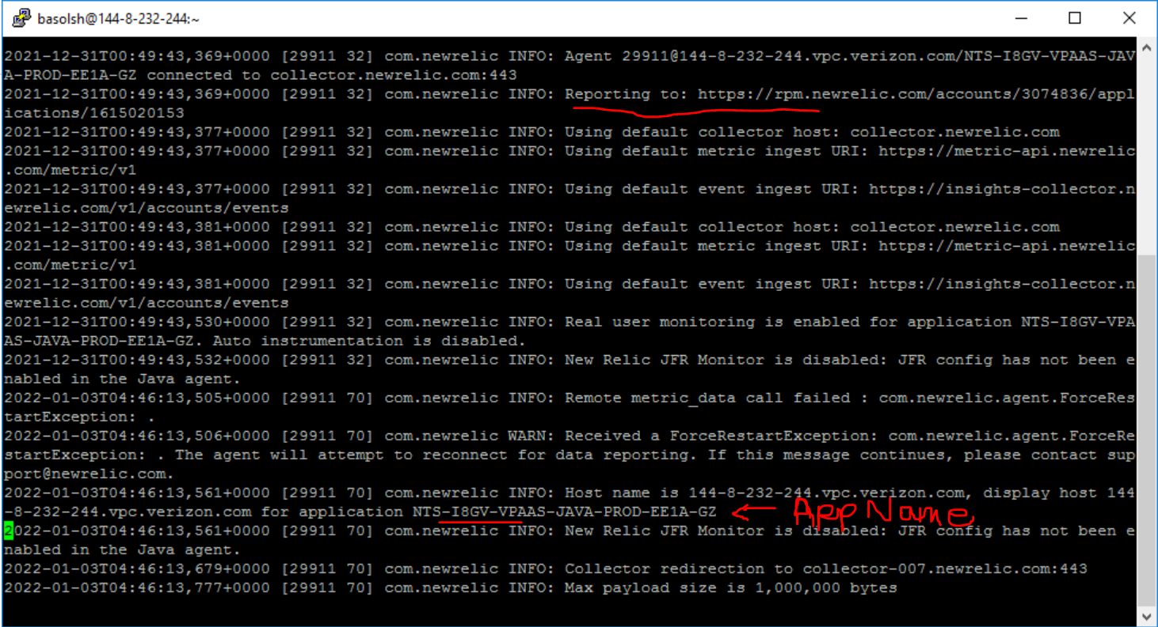

**Dashboard URL**

**Go to** [**https://rpm.newrelic.com/accounts/3074836/applications/1615020153**](https://rpm.newrelic.com/accounts/3074836/applications/1615020153) **and application metrics will be visible on the newrelic dashboard as shown below once applicaiton is accessed.**

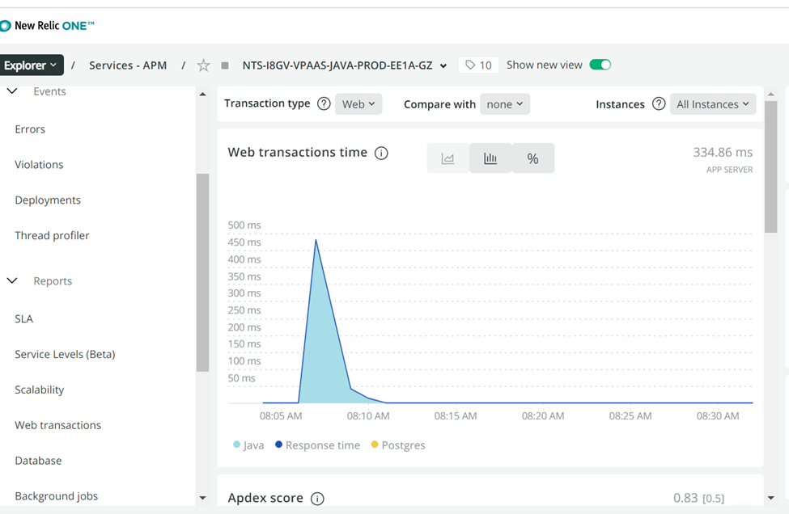

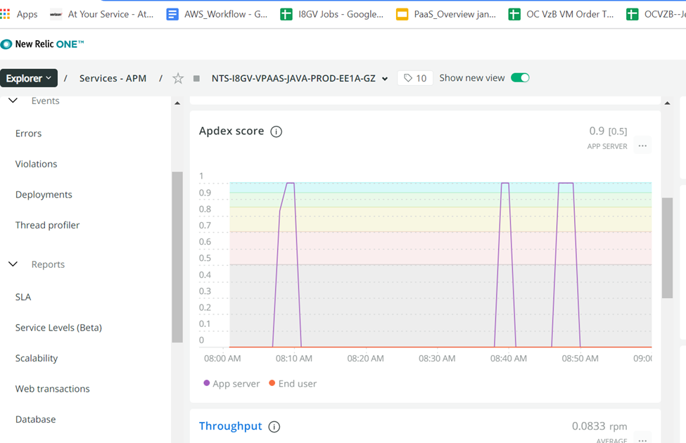

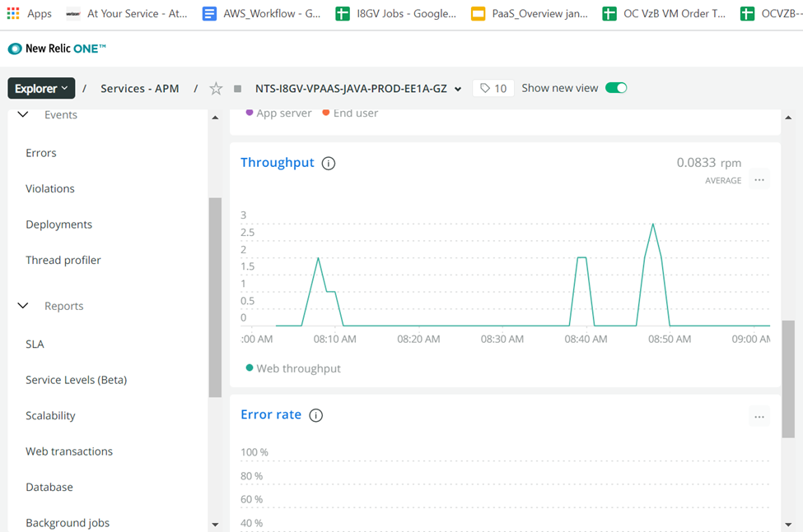

**STEPS FOR SERVER TO BE LISTED IN APM OF NEWRELIC UI :**

**For server to be listed in apm, we have to do following configuration changes in newrelic-infra.yml located at /etc**

1. **Cd /etc**
2. **Vi newrelic-infra.yml and add following content**

**license_key: 16d0b79a0ebe0c375abc3308598d6610FFFFNRAL**

**proxy: http://vzproxy.verizon.com:80**

**ignore_system_proxy: true**

**disable_all_plugins: true**

**verbose: 0**

**metrics_process_sample_rate: 30**

**log_file: /var/log/newrelic-infra/newrelic-infra.log**

**enable_process_metrics: true**

**custom_attributes:**

**nrVSAD: I8GV**

**nrENVT: PRD**

**nrPlatform: AWS**

**nrPOC:** [**VZ.NET.VPAAS.VzB.Scrum.TEAM@verizon.com**](mailto:VZ.NET.VPAAS.VzB.Scrum.TEAM@verizon.com)

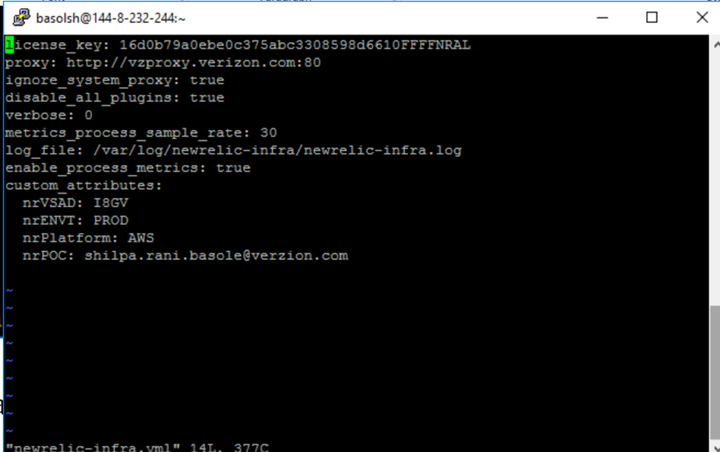

**Note: before making above changes, the content in newrelic-infra.yml will be as shown in following pic.  Therefore we need to delete existing content and add above content.**

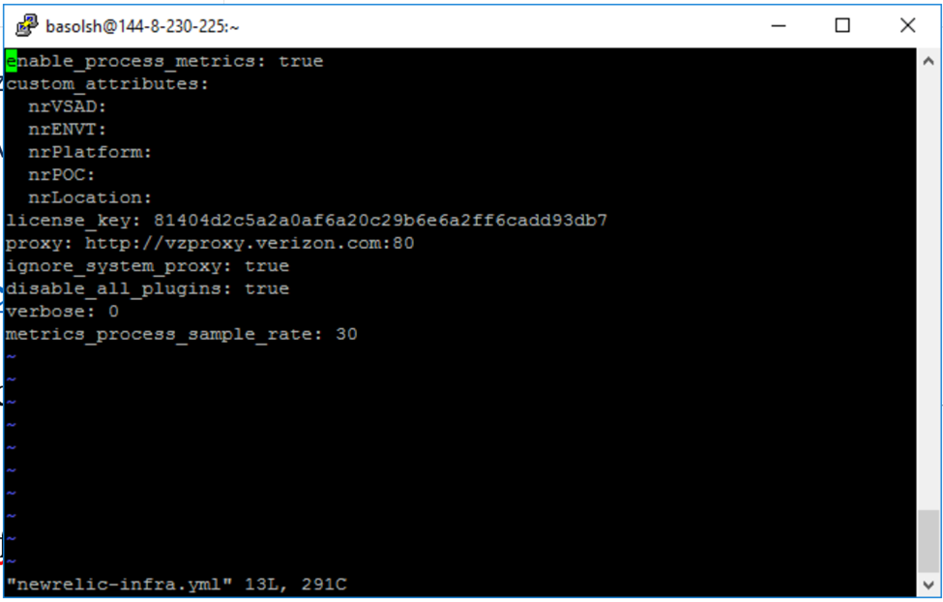

**After saving the newrelic-infra.yml file, we have to start newrelic-infra and command is**

**systemctl restart newrelic-infra**

**systemctl status newrelic-infra**

**Once newrelic-infra.yml is restarted the server will be visible in NewRelic dashboard as shown in below pic**

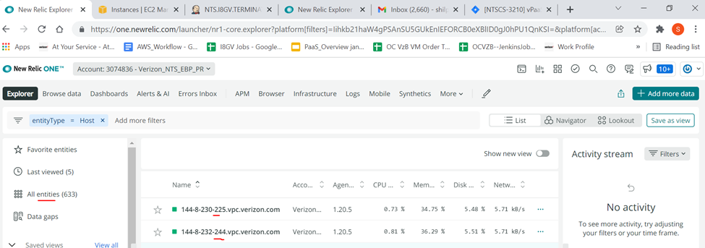

**PROCESS TO GET ACCESS TO NEWRELIC UI DASHBOARD:**

**We have to raise access request for getting access to Newrelic UI**

**Go to** [**https://maasportal.ebiz.verizon.com/automations/nruseraccess/**](https://maasportal.ebiz.verizon.com/automations/nruseraccess/)

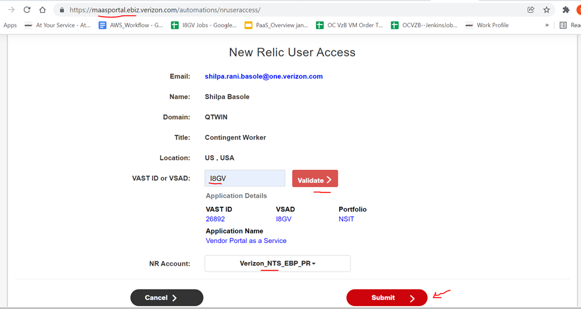

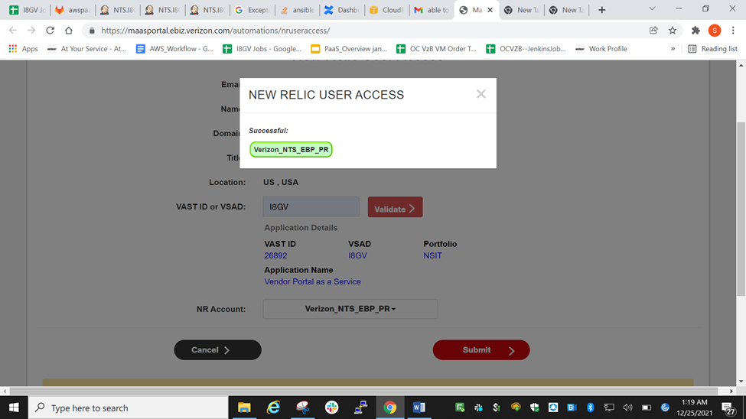

**EXPLANATION OF HOW INSTANCES ARE VISIBLE IN NEWRELIC UI**

**All instances that get created through ASG will have same appname. Therefore, all instances will be listed under the app name that is given in newrelic.yml.**

**Like shown in below pic**



**Below pic shows the instances Created by ASG that are listed under same app_name**

There are two Instances created at the time of deployment and they are listed in All instances as shown below

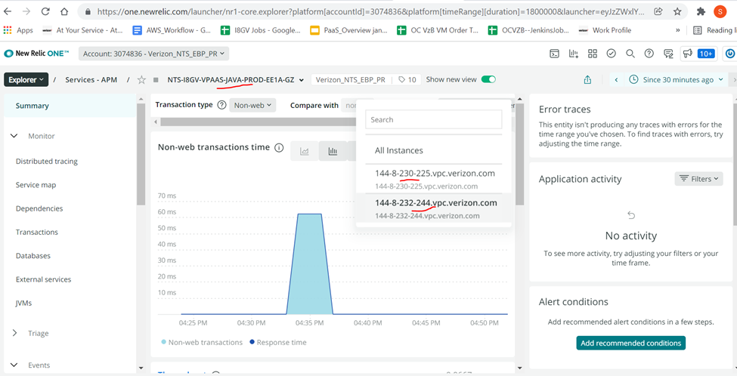

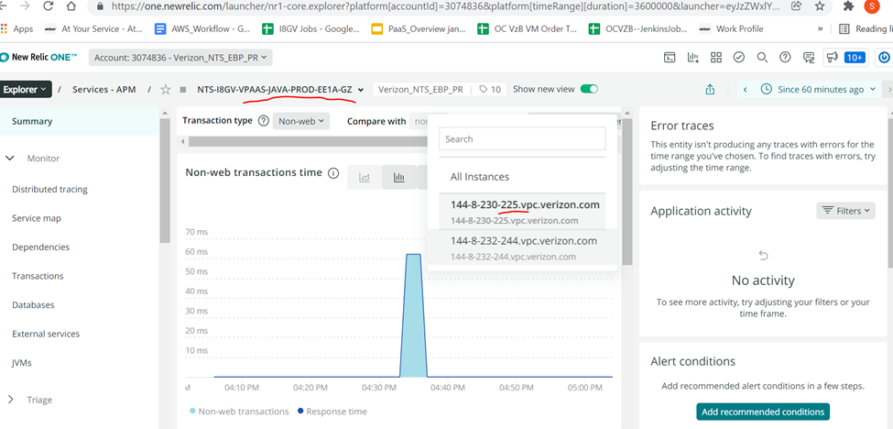

**URL TO ADD NOTIFICATION CHANNEL FOR POLICIES**

**Go to —-** <https://maasportal.ebiz.verizon.com/tools/notificationchannel/>

Under tool click on New Relic Notification Channel

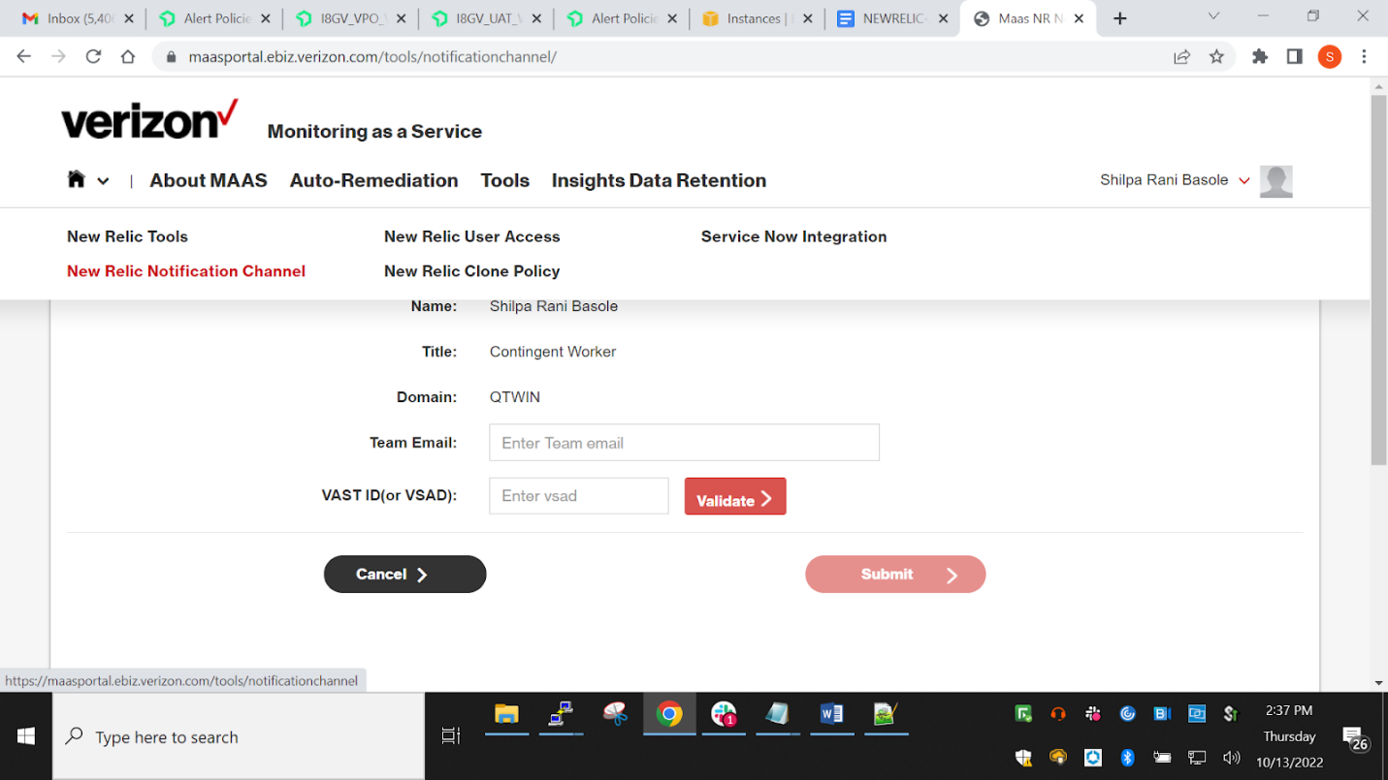

Enter details as shown in following pic  and click submit button

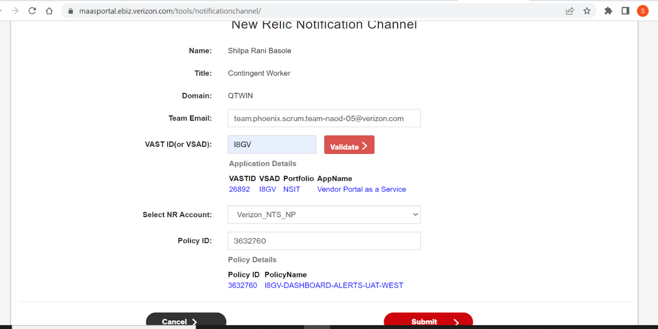

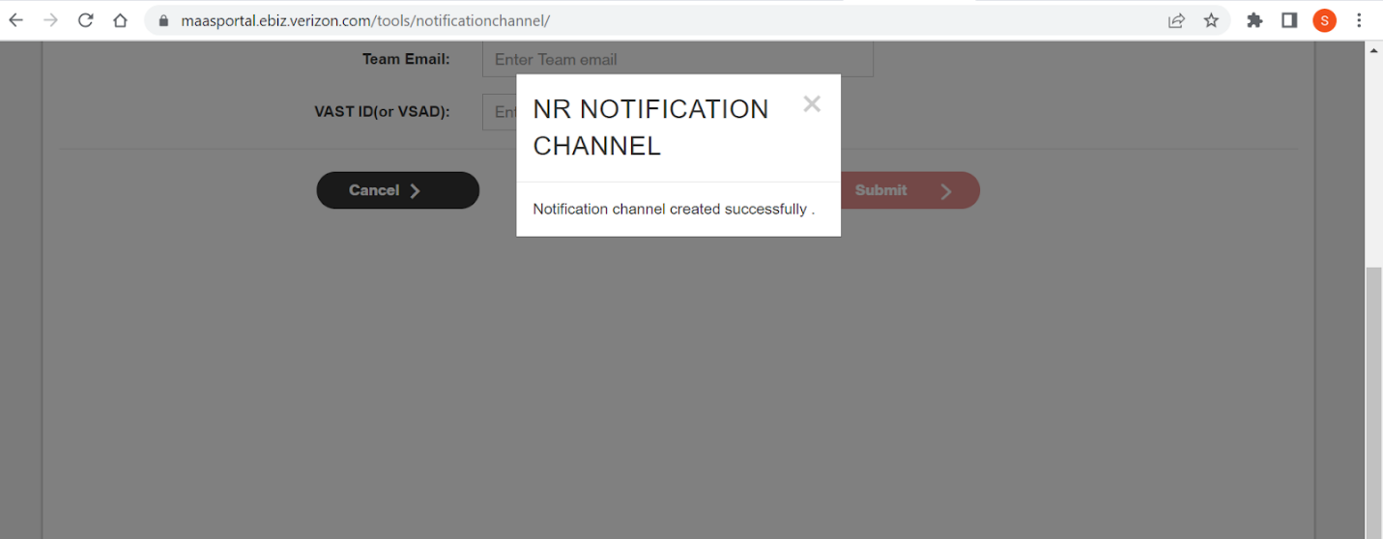

_______________________ALERTS__________________

<https://onejira.verizon.com/browse/DKVA-6756>  (prod code snippet – old )

<https://onejira.verizon.com/browse/DKVA-6897> (PROD code snippet – east and west in ebp_pr )

<https://onejira.verizon.com/browse/DKVA-6898> (UAT code snippet)

<https://web.dev/vitals/>

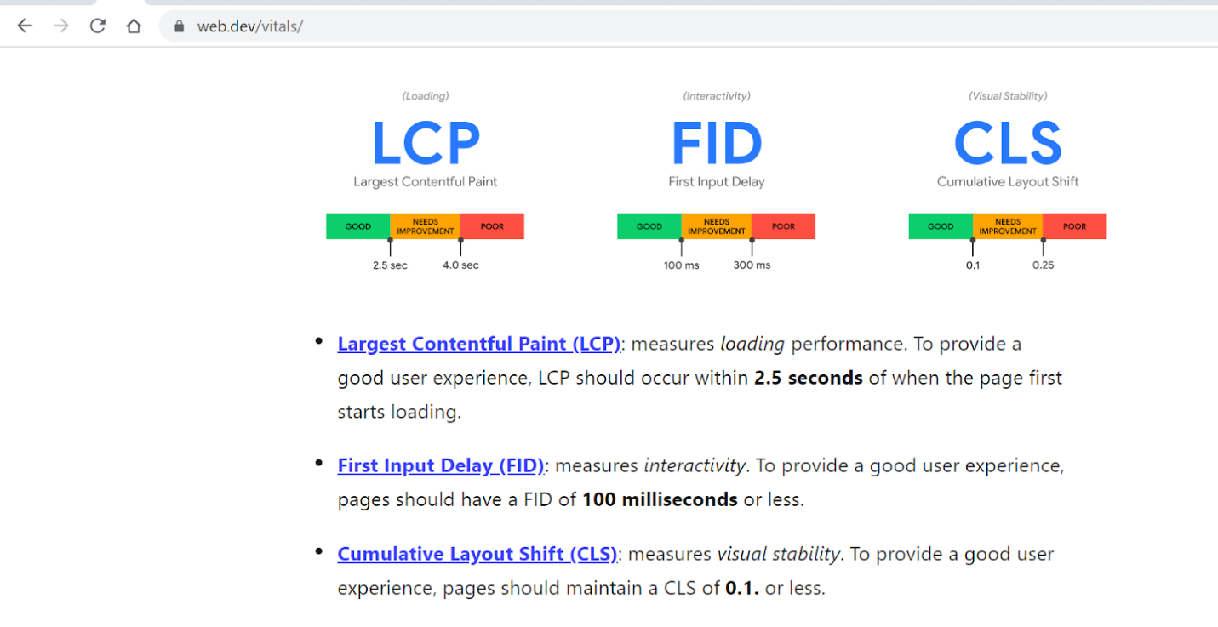

After code snippet is added to code, its build and deployed on server. Then vgui and vpo are shown on newrelic dashboard under dashboard with following names

Under each application, we have following default metrics for which we can create alerts

Had discussion with Gylynch and short listed on metrics for which alerts can be created and minimum threshold values :

**URL TO ADD NOTIFICATION CHANNEL FOR POLICIES**

<https://maasportal.ebiz.verizon.com/tools/notificationchannel/>

Sample newrelic-infra.yml :

license_key: xxxxxxxxxxxx

proxy: http://vzproxy.verizon.com:80

ignore_system_proxy: true

log_file: /var/log/newrelic-infra/newrelic-infra.log

disable_all_plugins: true

metrics_process_sample_rate: 30

enable_process_metrics: true

verbose: 0

custom_attributes:

 nrVSAD: AD4V

 nrPlatform: Onprim

 nrENVT: PRD

 nrPOC: adr-it@verizon.com

 nrMigrated: Y

Actual newrelic-infra.yml in vppas prod

license_key: 16d0b79a0ebe0c375abc3308598d6610FFFFNRAL

proxy: http://vzproxy.verizon.com:80

ignore_system_proxy: true

disable_all_plugins: true

verbose: 0

metrics_process_sample_rate: 30

log_file: /var/log/newrelic-infra/newrelic-infra.log

enable_process_metrics: true

custom_attributes:

  nrVSAD: I8GV

  nrENVT: PRD

  nrPlatform: AWS

  nrPOC: team.phoenix.scrum.team-naod-05@verizon.com

  nrMigrated: Y

____________________________

After policy is created, we need to get access for adding notification channel

<https://maasportal.ebiz.verizon.com/tools/notificationchannel/>

Fill the form as below and click submit

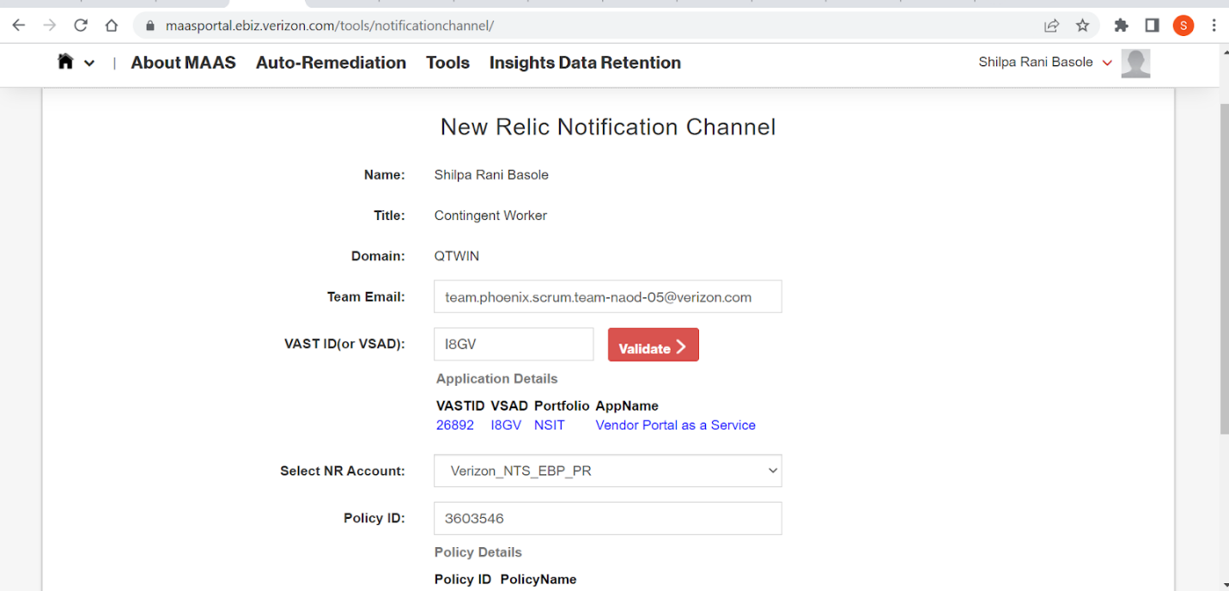

Newrelic process :

----------------------------________________ADITYA setup__________

RUM integration for UAT

### Step 1: Integrate the java script in <HEAD> </HEAD> tags in each page

Copy the code snippet, then paste it inline into your pages as close to the top of the <head> element as possible, but after any position-sensitive <meta> tags (for example, X-UA-Compatible or charset information).

For more information on the inline head placement, see JavaScript placement requirements.

Please follow this link for reference,

<https://docs.newrelic.com/docs/browser/new-relic-browser/installation/install-new-relic-browser-agent>

The code snippet can be found in the below links

UAT

[https://drive.google.com/file/d/1FlM0iHxeLabBJyvXFFeRIW0acm4BCMlr](https://drive.google.com/file/d/1FlM0iHxeLabBJyvXFFeRIW0acm4BCMlr/view?usp=sharing)

**Please put in the head section after meta tags. This should be the first step in the script section.

### Step 2: Build and deploy changes to reflect in the corresponding environment

### Step 3: Add the mandatory NR tags as per the confluence

Confluence link: <https://oneconfluence.verizon.com/pages/viewpage.action?pageId=661617578>

Reference to add tags

<https://docs.newrelic.com/docs/browser/new-relic-browser/browser-agent-spa-api/setattribute-browser-spa-api/>

### Step 4: Verify the Metrics in RUM Dashboard-NewRelic Browser